CL-1002 Programming Fundamentals | LAB - 05  Basic Decision Structure
NATIONAL UNIVERSITY OF COMPUTER AND EMERGING SCIENCES
Fall 2022
NATIONAL UNIVERSITY OF COMPUTER AND EMERGING SCIENCES
NATIONAL UNIVERSITY OF COMPUTER AND EMERGING SCIENCES
NATIONAL UNIVERSITY OF COMPUTER AND EMERGING SCIENCES

Learning Objectives

- Introduction to conditional statements

- If structure

- If –else structure

- If-else-if structure

- Switch statements

Conditional Statements
In C programming there are decision making statements, we need this kind of statements because while programming we often need to make a lot of decisions. Like shown below in the pictures.
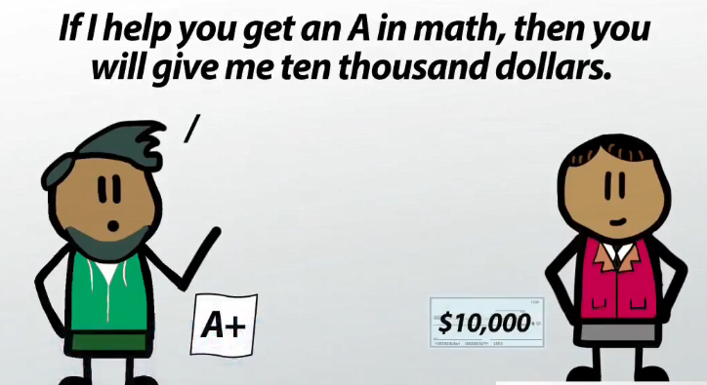

In some cases, we need to execute this block of code
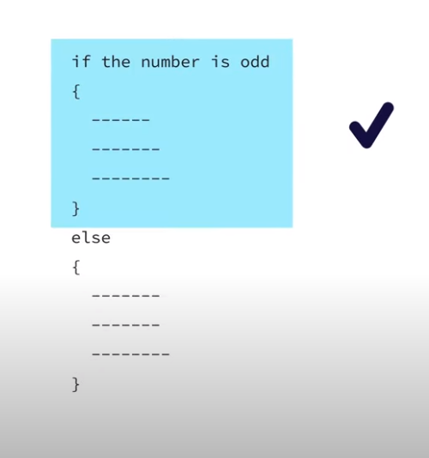
Otherwise, we want to execute this block
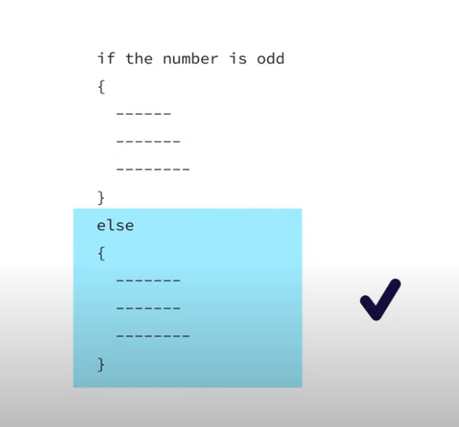
In C, an if/else statement specifies that one block of code should be executed if a condition is true, and another block should be executed if that condition is false.
To write meaningful if/else statements, it is important to know operators which allow us to compare two expressions and produce a Boolean outcome.
In C, however, there are no distinct values for true or false, instead, false is 0, and anything which is non-zero is true. We will refer to true and false because they make more sense conceptually; the distinction should not make a practical difference in most cases.
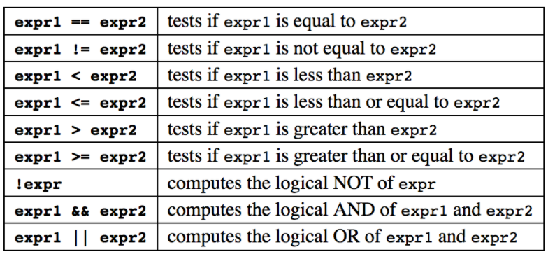
In 'C' programming conditional statements are possible with the help of the following two constructs:
1. If statement
2. If-else statement
It is also called as branching as a program decides which statement to execute based on the result of the evaluated condition.

If statement
An if statement consists of a conditional expression followed by one or more statements.
If the conditional expression evaluates to true, then the block of code inside the if statement will be executed. If conditional expression evaluates to false, then the first set of code after the end of the if statement (after the closing curly brace) will be executed.

Syntax: The syntax of an if statement in C programming language is:
If (condition)
{
//statements;
}

Flowchart:
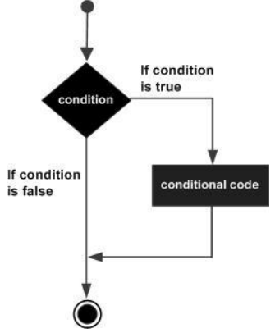

Example: Checking if the number input by user is 0 or not. If its 0 then print Zero else print non-zero
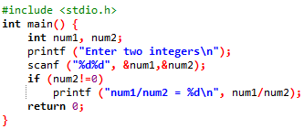
If else statement
An if statement can be followed by an optional else statement, which executes when the Boolean expression is false.
Syntax: The syntax of an if...else statement in C programming language is:
If (condition)
{
//statements;
}
else
{
//statements;
}

Flowchart:
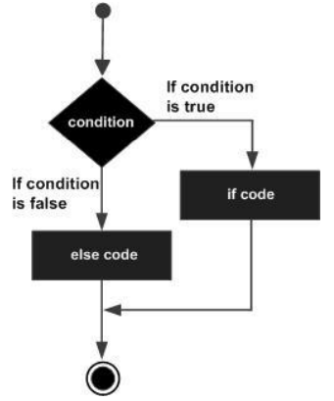

Example:
Checking the value of variable a, if it contains 10 then print value of a is 10, if it contains 20 then print value of a is 20, if its 30 then print value of a is 20 otherwise print None of the value is matching

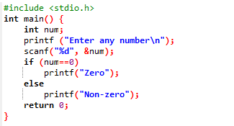

If else if statement
An if statement can be followed by an optional else if...else statement, which is very useful to test various conditions using single if...else if statement.

When using if, else if, else statements there are few points to keep in mind:
- An if can have zero or one else's and it must come after any else ifs.
- An if can have zero to many else if's and they must come before the else.
- Once an else if succeeds, none of the remaining else if's or else's will be tested.
Syntax: The syntax of an if...else statement in C programming language is:
Example:
#include <stdio.h>
int main () {
int a = 100;
if( a == 10 ) {
printf("Value of a is 10\n" );
} else if( a == 20 ) {
printf("Value of a is 20\n" );
} else if( a == 30 ) {
printf("Value of a is 30\n" );
} else {
printf("None of the values is matching\n" );
}
printf("Exact value of a is: %d\n", a );
return 0;
}

Problem
In FAST University 80% attendance is required for students to appear in the examination otherwise you won’t be able to sit in an exam.
Algorithm
Start
Input attendance of semester
IF attendance>=80
then
print “You are eligible for the Examination”
ELSE
print “Sorry you are not eligible for Exam”
END IF
END

Flowchart
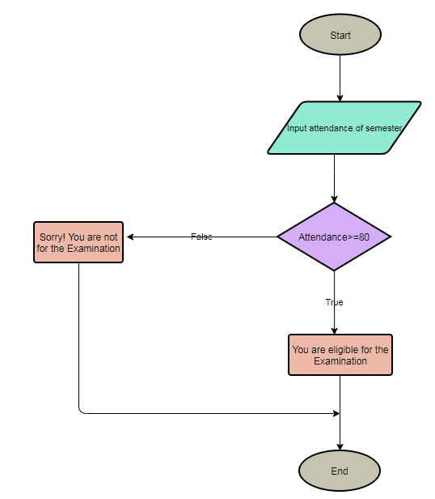
C Code
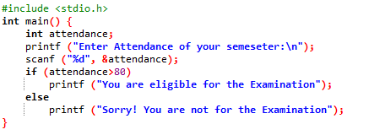

Problem
FAST University wants to assign a grade to every PhD student according to the obtained marks. The grading criteria for the PhD students is given below.
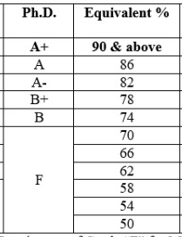

Write a program to assign the grade to each student according to his marks.
Start
Input marks
IF marks>=90
then
print “You have got A+ grade”
ELSE
IF marks>=86
then
print “You have got A grade”
ELSE
IF marks>=82
then
print “You have got A- grade”
ELSE
IF marks>=78
then
print “You have got B+ grade”
ELSE
IF marks>=74
then
print “You have got B grade”
ELSE
print “You are fail”
END IF
END

Algorithm
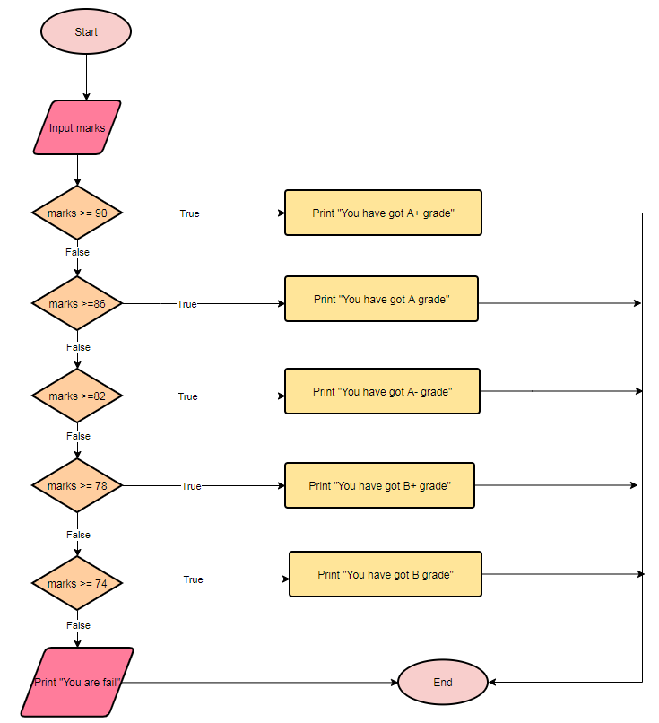

C Code
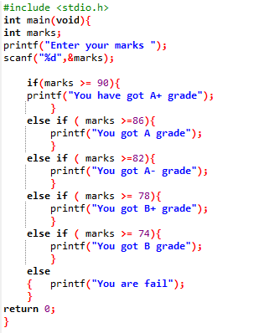

Switch Statement
Another way that programs can make decisions is to use switch/case. The syntax of switch/case is shown in the figure below.
Syntax:
switch (selection expression) {
case 1:
//statement
break;
case 2:
//statement
break;
default:
//statement
}

Here, when the execution arrow reaches the switch statement, the selection expression—in parenthesis after the keyword switch—is evaluated to a value.
This value is then used to determine which case to enter. The execution arrow then jumps to the corresponding case—the one whose label (the constant immediately after the keyword case) matches the selection expression’s value. If no label matches, then the execution arrow jumps to the default case if there is one, and to the closing curly brace of the switch if not.
✔

switch (selection expression)

int / char
float / string

The following rules apply to a switch statement:
- The expression used in a switch statement must have an integral or enumerated type or be of a class type in which the class has a single conversion function to an integral or enumerated type.
- You can have any number of case statements within a switch. Each case is followed by the value to be compared to and a colon.

Switch statement is better than if else statement
A switch statement is usually more efficient than a set of nested ifs
Switch statement acts as a substitute for a long if-else-if ladder that is used to test a list of cases.
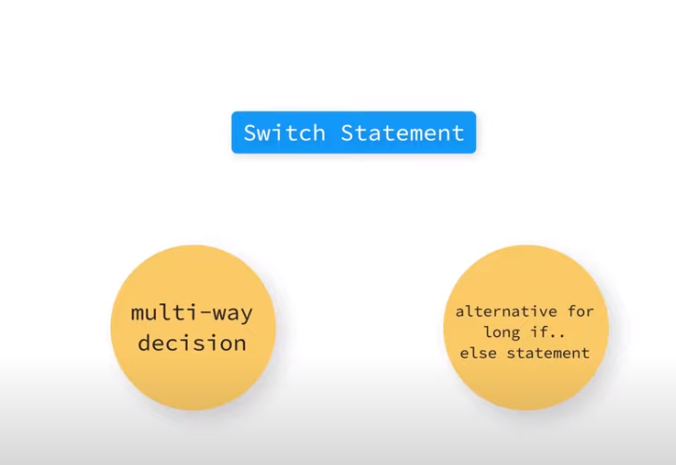

Flowchart

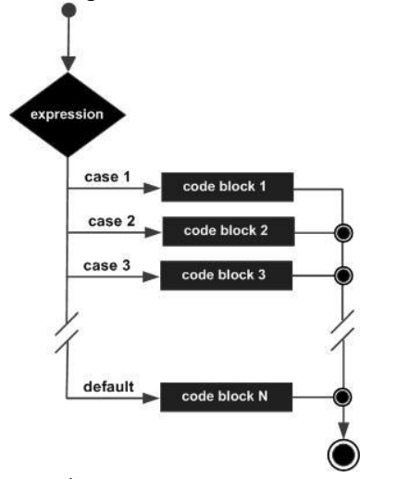

Example: Calculator using numbers to choose operators, if 1 is pressed then addition is performed, if 2 is pressed then subtraction if 3 is pressed then multiplication, if 4 is pressed then division otherwise print invalid choice.
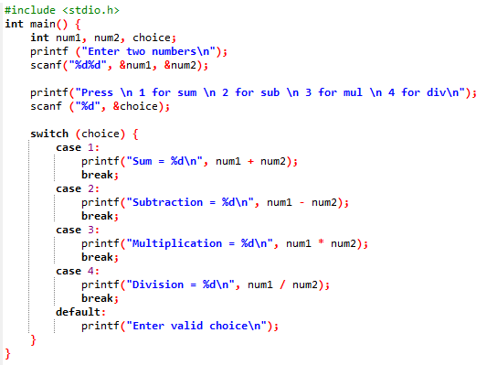

Output:
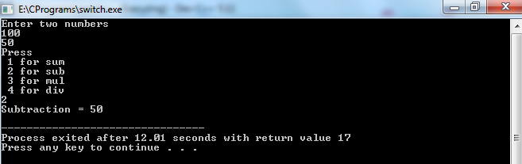
Lab Tasks
- Write a C program to check whether a number is multiple of 3 or not. If it is then print “This number is multiple of 3”, otherwise print “This number is not multiple of 3”.
- Create a calculator asking for operator (+ or – or * or /) and operands and perform calculation according to the user input using switch statement.
- Write a C program to input a character from user and check whether given character is small alphabet, capital alphabet, digit, or special character, using if else.
- An online shopping store is providing discounts on the items due to the Eid. If the cost of items is less than 2000 it will give a discount up to 5%. If the cost of shopping is 2000 to 4000, a 10% discount will be applied. If the cost of shopping is 4000 to 6000, a 20% discount will be applied. If it's more than 6000 then 35% discount will be applied to the cost of shopping. Print the actual amount, saved amount and the amount after discount. The Minimum amount eligible for a discount is 500.
- An android developer wants to design a mobile feature to control the brightness of the mobile phone according to the surrounding light. In order to do it he uses an ambient light sensor (for the detection of surrounding light) which is commonly built in in all major android phones. It gives the value of light intensity in integers. Write a C program for Light sensor value ranges from 0-1000, if it's exposed under sunshine (>500), if it's evening then (0 ~ 100), lighting (100 to 500).

- Write a C program to find all roots of a quadratic equation, it is required to take user input for a, b, and c values. Find discriminant using formula
$discriminat=\left(b ×b\right)-(4×a×c)$
Compute roots based on the nature of discriminant.

- Write a program in C to calculate and print the Electricity bill of a given customer. The customer id., name and unit consumed by the user should be taken from the keyboard and display the total amount to pay to the customer. The charges are as follow:
Unit | Charge/Unit
Up to 199 | @16.20
200 and above but less than 300 | @20.10
300 and above but less than 500 | @27.10
500 and above | @35.90
If bill exceeds Rs. 18000 then a surcharge of 15% will be charged on top of the bill.
Test Input:
1001 //Customer ID
James //Customer Name
800 //Units Consumed
Expected Output:
Customer ID :1001
Customer Name: James
Units Consumed :800
Amount Charges @Rs. 35.90 per unit: 28720
Surcharge Amount: 4308
Net Amount Paid by the Customer: 33028.00

- Given a positive integer denoting n, do the following:
  - If 1<=n<=9, print lowercase English words corresponding to the numbers e.g. (one for 1, two for 2)
  - If n>9 print greater then 9
- Write a C program to check whether a triangle is Equilateral, Isosceles or Scalene (Use user input values).
Test Input:
50 50 60
Expected Output:
This is an isosceles triangle.

